**1. Getting Started - Tableau Workspace, Tableau terminologies, basic functionalities.**

(For Viva)

**2. Connecting to Data Source – Database and Tableau Joins**

**Dataset:** sample_superstore.xls (Sheets: Orders, Returns, People)  
**Steps to Connect to Excel in Tableau:**

1. Open Tableau → Click **Connect** → Choose **Microsoft Excel** under "To a File."

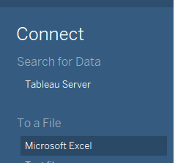

1. Browse and select sample_superstore.xls. The sheets appear in the Data Source tab.
2. Double Click “Orders” > Right click and select “Open”

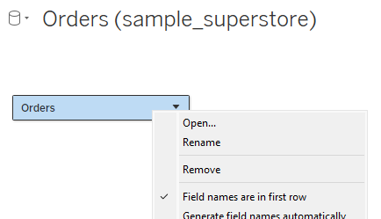

1. Drag “Returns” to “Orders”.

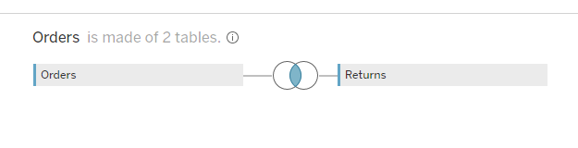

sample_superstore.xls Dataset: has three Excel sheets

• Orders:

Row ID

Order ID

Order Date

Ship Date

Ship Mode.....

• Returns:

Returned

Order ID

• People:

Person

Region

“Order” and “Returns” have a relationship based on the field “Order ID”, and you can join them using this field.

**Joins in Tableau:**

* **Inner Join:** Matches records in **Orders** and **Returns** by Order ID.
  + Double click on the Sheet “Orders” to bring it to the Relationship Window & to view the contents of the sheet.
  + Select “Orders” in the Relationship window, go to the drop-down menu in “Orders”, now click on “Open” in order to unlock the contents and to build a relation with other sheets.

Result: Only matched records appear.

* **Left Join:** Includes all records from **Orders** and matching ones from **Returns**; unmatched rows show NULL for Returns. Change join type to **Left Join**.
* **Right Join:** Includes all records from **Returns** and matching ones from **Orders**; unmatched rows show NULL for Orders. Select **Right Join**.
* **Full Outer Join:** Combines all records from both tables, filling unmatched rows with NULL. Select **Full Outer Join**.

**3. Creating Views: Formatting Charts, Filters, Calculated Fields, and Parameters**

**Dataset:** vgsales.csv

1. Open Tableau → Click **Connect** → Choose **More** under "To a File."
2. Click “Sheet 1” on the bottom of the window.

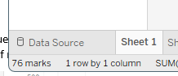

**Formatting Charts:**

1. Drag Year to Columns and then EU Sales & Global Sales to Rows for line charts.

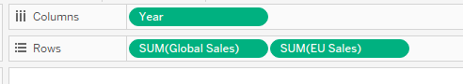

1. If we wish to change the graph of “EU Sales” from Line Chart to Bar Graph , Change EU Sales to a bar chart via **Marks Pane → Automatic → Bar**.

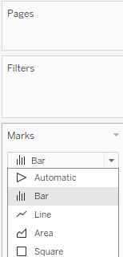

1. To indicate the values of each Bar, Go to Marks Pane → **Label** → Tick **Show mark labels** → Adjust **Font/Color** if needed.

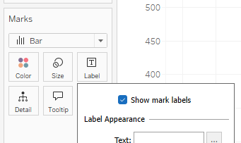

**Creating Calculated Fields:**

1. Create a new Sheet by clicking on the symbol ‘+’ near Sheet1.
2. Drag Year to Columns.
3. Right-click Global Sales → **Create → Calculated Field**.

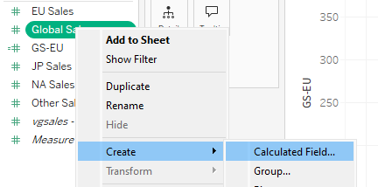

1. Rename the title “Calulcation1” with a meaningful name to remember as “GS-EU”.
2. Now, come to formulae window below and give the formulae as “[Global_Sales] –[EU Sales] “. Click on “Apply”, then “OK”.



1. Drag GS-EU to Rows to visualize the new line chart. If Line chart doesn’t appear then   
   **Marks Pane → Automatic → Line Chart**.

**Adding Filters:**

1. Create a new Sheet by clicking on the symbol ‘+’ near Sheet2.
2. Drag Year to Rows and “Genre” to Columns.

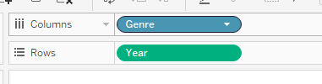

1. Drag and drop the field “Genre” to “Filters”. Now all values are selected automatically.
2. Uncheck all → Select specific genres and Hit Ok.

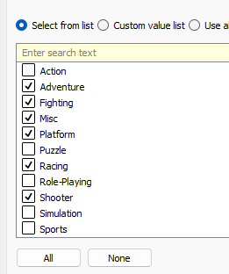

1. If Line chart doesn’t appear then   
   **Marks Pane → Automatic → Line Chart**.
2. Add Genre to “Color” to have random colors.

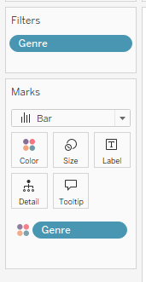

**Defining Parameters:**

1. Create a new Sheet by clicking on the symbol ‘+’ near Sheet3.
2. Right-click Global Sales → **Create → Parameter**, Rename it **GSMAX**, and hit OK.

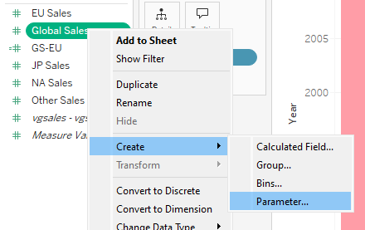

1. Drag and drop the field “Year” to the Columns.
2. Right-click GSMAX → **Create → Calculated Field**, name it **MAX of GS**, and type the formula max([GSMAX]).

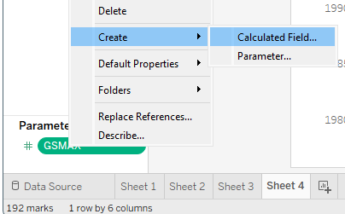

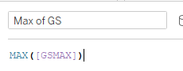

1. Drag MAX of GS to Rows and change the chart type to **Area Chart** and “Genre” to Color.

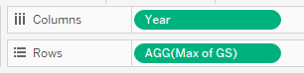

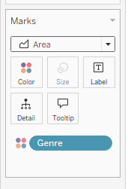

**4. Dashboard Design and Storytelling – Components of Dashboard, Understanding how to place**

**worksheets in Containers, Action filters and its types.**

**Dataset used:** Global Superstore.xlsx

Preparation

1. Join Data: Double Click > Right Click> Open the Sheet “Orders” and then join the sheet “Returns” as INNER JOIN which has “Order ID” as the common field.
2. Sheet 1 (Map):
   * Double-click on the field “State” under “Orders” to create a map. Select a state-based map in "Show Me". From the “Show Me” area, choose the map that selects the entire region of a state in India instead of just a dot appearing on the map.

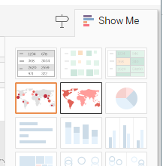

* + Rename to "Map" and title it "Map Selector".

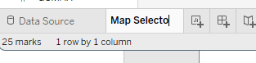

1. Sheet 2 (Sales):
   * Drag Order ID to Columns and Sales to Rows (from Orders).

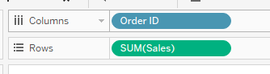

* + Rename to "Sales" and title it "Sales Details".

1. Sheet 3 (Quantity):
   * Drag Order ID to Columns and Quantity to Rows (from Orders).
   * 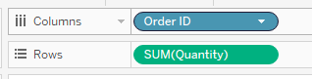
   * Rename to "Quantity" and title it "Quantity Details".

Create Dashboards

1. Dashboard 1 (All 3 DB):
   * Create Dashboard-1 by clicking on ‘+’ symbol at the bottom near to Sheet.

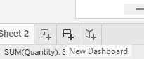

* + Set layout to Tiled.

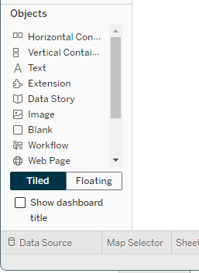

* + Add:
    - Insert a “Blank” object by double clicking on the object “Blank”.

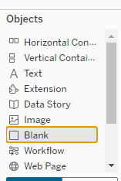

* + - Add Horizontal Container, in it Place the "Map" sheet.

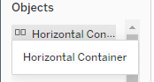

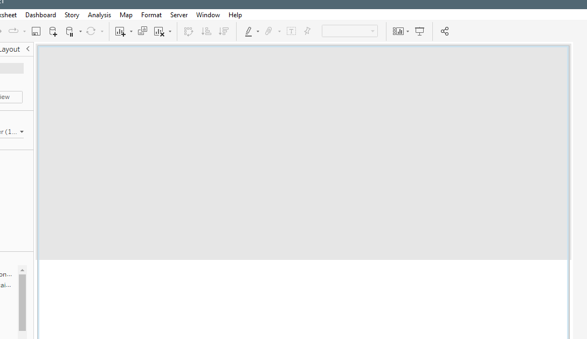

* + - Add 2 Vertical Containers in them Place "Sales" and "Quantity" sheets side by side.

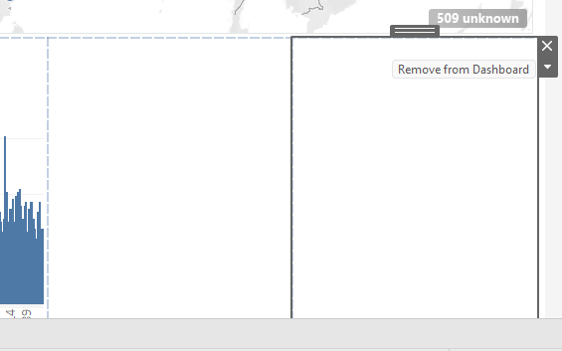

Note: While placing the last Vertical Container if it fills only the left half then hit remove from Dashboard on the box with the Gray Border.

* + Rename as "All 3 DB".

1. Dashboard 2 (Sales DB):
   * Drag "Sales" sheet. Rename as "Sales DB".
2. Dashboard 3 (Quantity DB):
   * Drag "Quantity" sheet. Rename as "Quantity DB".
3. Dashboard 4:
   * Create a “Blank” object
   * Add a Horizontal Container.
   * Drag the sheet “Map” to this “Horizontal container”. Drag the “Image” object onto the bottom part of the “Horizontal container”. Choose an image from the computer & select the option as “Fit Image” and click Apply followed by OK.
     + Add a Navigation Object to link to "All 3 DB". Double Click on the “Navigation” object (or)
     + Choose “Edit Button” to decide where to Navigate.
     + we can select “Navigate To”→”All 3 DB”. Then choose Apply followed by OK.

Add Activity Filter

* Action Filter (All 3 DB):
  + From menu Dashboard → Actions → Add action→ Add Filter:

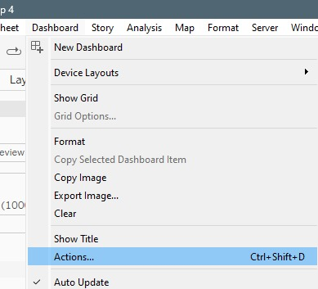

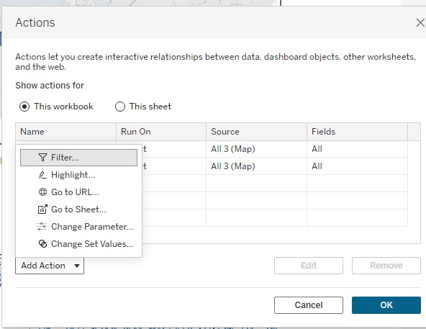

* + - Source: Select "Map" only uncheck “Quantity”, “Sales” → Under “Run action on” choose “Select”.
    - Target: Select "Sales" and "Quantity" → From the option “Clearing the selection will”, choose “Show all values”. Then click OK.
    - On selection: Show filtered values; on clear: Show all values.

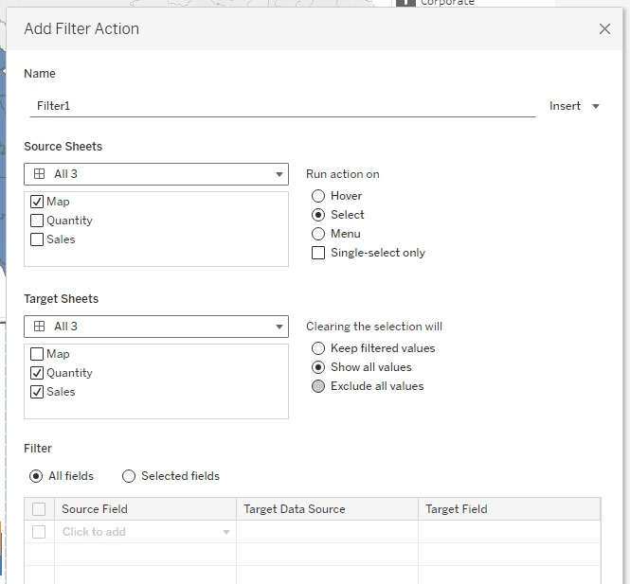

**5. Introducing Power BI –Components and the flow of work. Power BI Desktop Interface-The Report has five main areas.**

(**Viva)**

**6, Querying Data from CSV - Query Editor, Connecting the data from the Excel Source, Clean, Transform the data.**

**Dataset:**  CustomerMaster.xlsx

**Connect to Data in Power BI Desktop**

1. Open Power BI Desktop and click on Blank Report.
2. Go to the Home tab, select Get Data, and choose your data source (e.g., Excel, CSV, Oracle).
3. Select the file select the file that has the “Table” Icon, open it, and use the Navigator window to:
   * Load the table directly or
   * Select Transform Data to make changes using Power Query Editor.

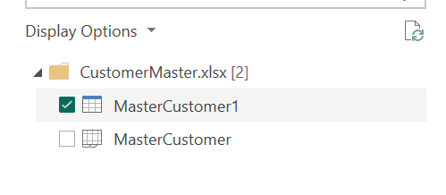

**Transforming Data from an Excel File**

1. Check for the datatype automatically applied by PowerBI. If required, change it.
2. Remove Unnecessary Columns:
   * Right-click on the column to be removed and choose “Remove”
     1. Delete irrelevant fields like *DeliveryMethod*, *WebsiteURL*, etc.
   * Go for “Choose Columns” from the ribbon and uncheck the columns that are not required
     1. Uncheck “PhoneNumber”, “FaxNumber”, “PrimaryContact”

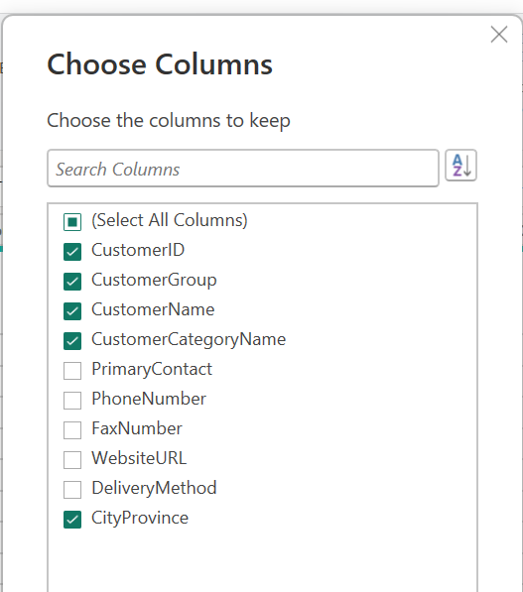

1. Split Columns:
   * Right-click on “*ProvinceCity”* →Split Column→By Delimiter( mention the Custom delimiter as ‘(‘ ).

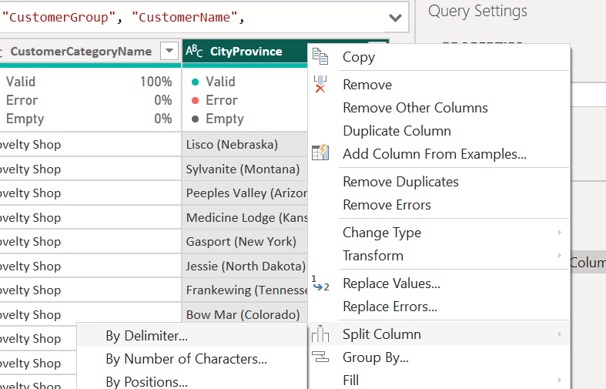

* + Now, we get a new column created with Province name followed by ‘)’. To remove this ‘)’. Right-click→Split Column→By Delimiter( mention the Custom delimiter as ‘(‘

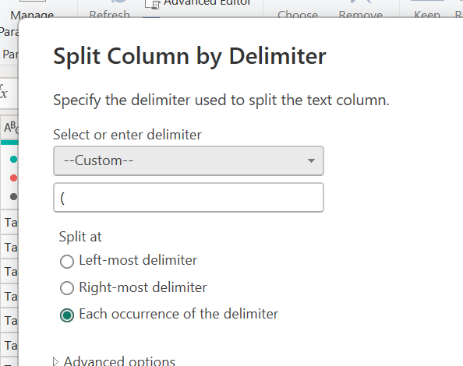

* + Delete that column which has only ‘)’.
  + Rename the column “CityProvince1” as “City”, “CityProvince2” as “Province”.

1. Handle Duplicate Columns:
   * Since the data regarding “CustomerGroup” is repeating in two different columns, we can delete one column with the name “CustomerGroup” first and modify the other column as follows
   * Right-click on “CustomerName”, Split Column→By Delimiter.
   * Remove the ‘)’ from the “CustomerName 2” column.
   * Rename the columns “CustomerName1” as “CustomerName” and “CustomerName2” as “Head Office”.

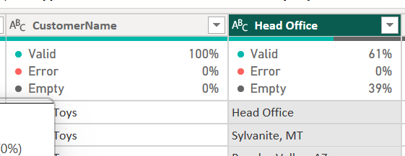

1. Handle Null Values:
   * Create a new column using conditional logic to indicate "Head Office Exists" or "No Head Office".

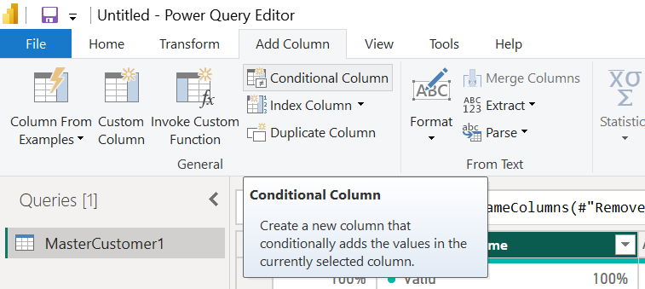

* + Click on “Add Column”, Rename as “Head Office Status”.
  + Then mention the condition in that window as “if Head Office equals null No Head Office” “else Head Office Exists”.

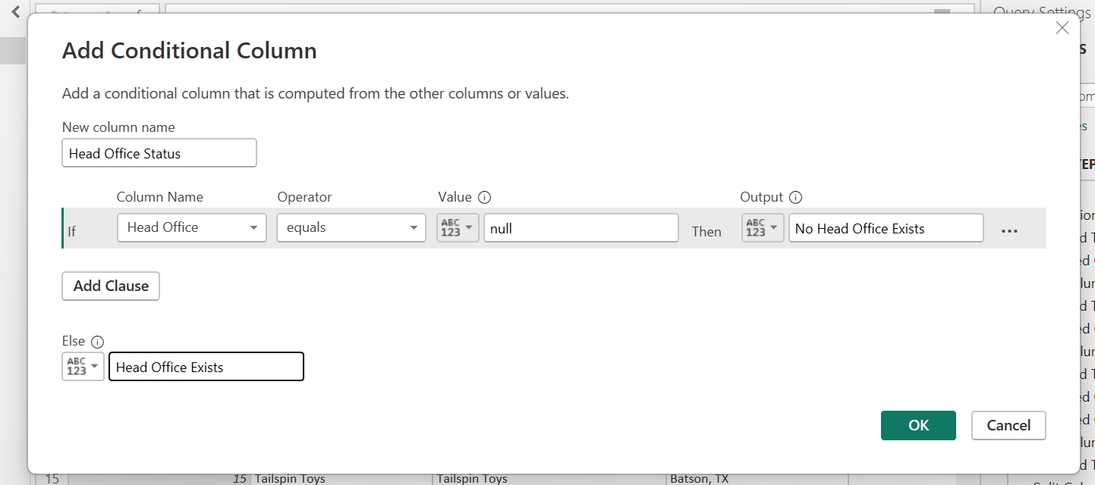

1. Rename Table: Update the table name to “Customer”. Then **File > Close & Apply**

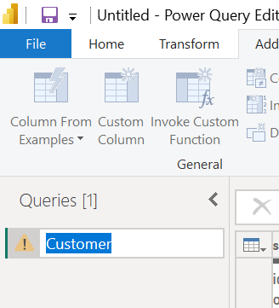

**Transforming Data from a Text/CSV File**

**Dataset:** invoice.txt

1. Click on “Get Data→Text/CSV”, and choose the invoice.txt
2. Transform the data. Change the data type of the column “Sales” from “Whole number” to “Fixed decimal number” type by clicking on the “123” Icon.

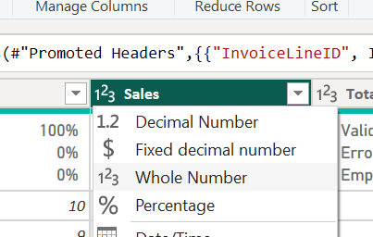

1. Remove Unnecessary Columns: Delete columns like *TotalChillerItems*.
2. Merge Date Columns:
   * Combine *Day*, *Month*, and *Year* into a single *Date* column .
     1. Select the 3 columns by pressing Ctrl + “Day”,”Month”,Year”, then right-click and choose the option as Merge. (Select them in the correct order)

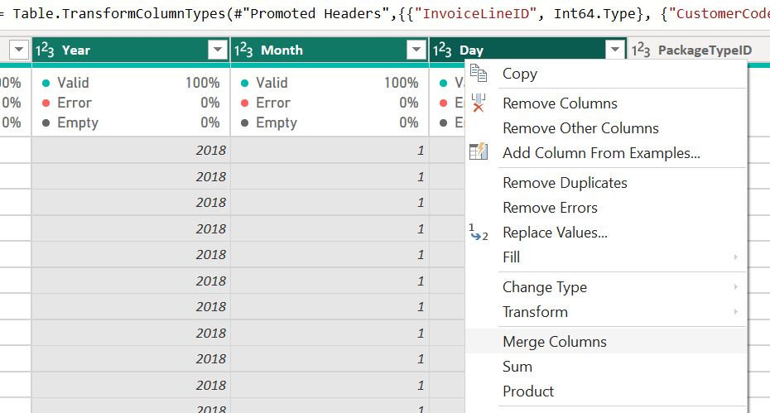

* + 1. Separator as “Custom”, then give the symbol ‘/’ followed by a new column name as “Date”.

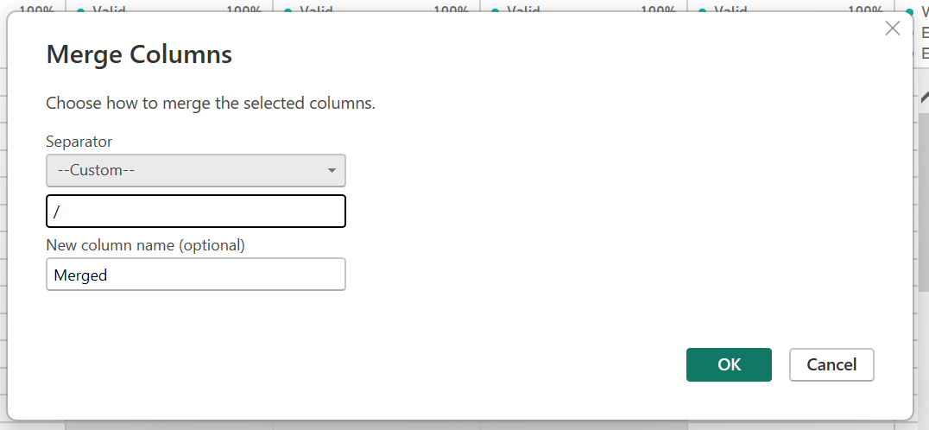

* + 1. Change its data type to *Date*.

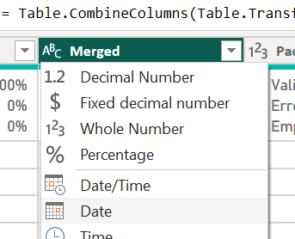

1. **Creating Reports & Visualizations - Different types of charts, Formatting charts with Title, Colors.**

**Creating Reports & Visualizations in Power BI**

**Dataset**: *CustomerMaster.xls* (Ensure the Date field is correctly formatted to "Date" datatype as per Experiment 6 for analysis.)

1. **Canvas Background**:
   * Go to *Visualizations → Format your report page → Canvas Background*.
   * Choose a color, reduce transparency to apply it.

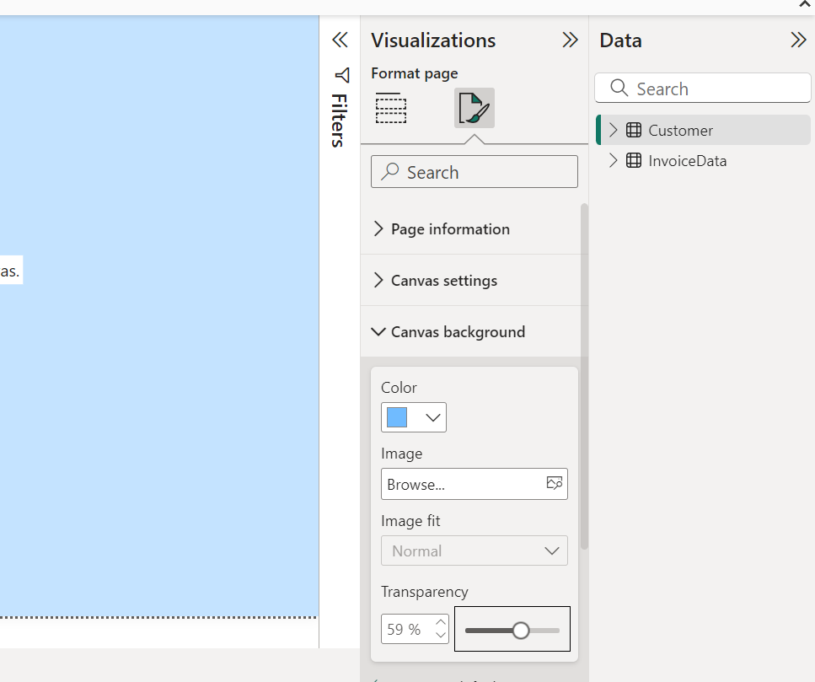

1. **Title**:
   * Add a text box, type *"Customer & Invoice"*, make it bold, center-justified, and style it. Place it at the center of the canvas.

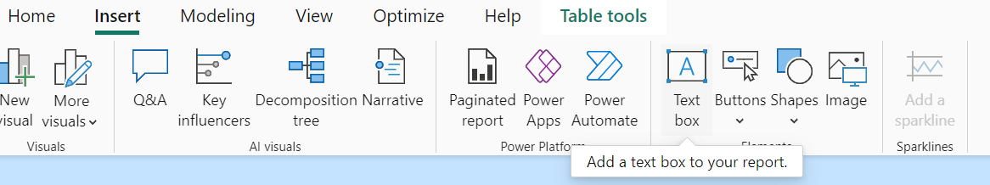

1. **City-wise Total Sales**:
   * Go to “Visualizations→Build Visual”, Choose “Stacked Bar Chart”

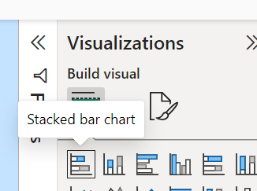

* + Drag *Sales* from “Invoice table” to X-axis and *City* from “Customer table” to Y-axis.

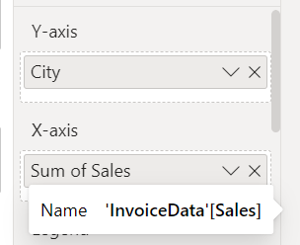

* + Use *Focus Mode* to view detailed sales data in tooltips. When we hover the mouse, we can get the sales details of each city as a tooltip.

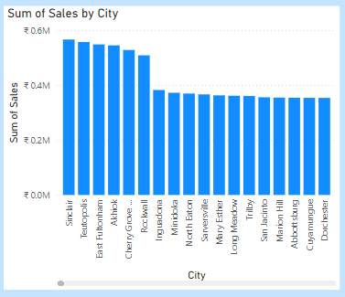

1. **Province-wise Sum of Sales**:
   * Go to “Visualizations→Build Visual”, Choose “Stacked Column Chart”
   * Drag *Sales* to X-axis *and Province* to Y-axis.

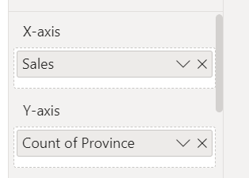

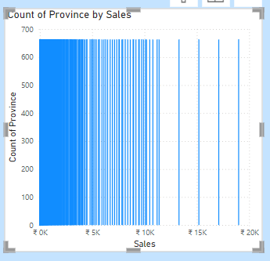

1. **Interaction Example**:
   * Click on a specific province (e.g., *Texas*) to highlight city-specific sales in the City-wise chart. This feature in PowerBI is known as INTERACTION.
2. **KPI Card**:
   * Ensure no charts are selected.
   * Go to “Visualizations→Build Visual”, Choose “Card”.

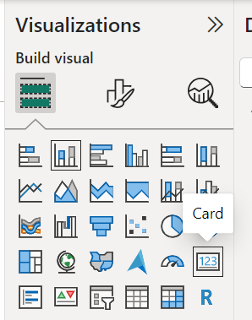

* + Ddrag the *Sales* field onto it to display total sales.

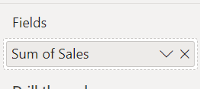

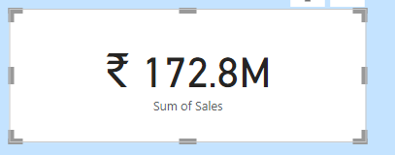

1. **Year-wise Sales Slicer**:
   * Go to “Visualizations→Build Visual”, Choose “Slicer”.

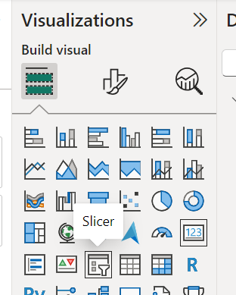

* + Go to “Data” pane and choose “Date→Date Hierarchy” and select *Year* to display available years.

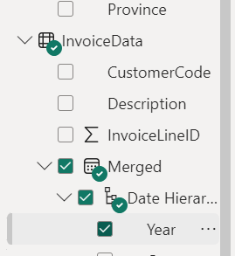

* + Change the style to ***Vertical List*** in ***Format Visual → Slicer Settings***.

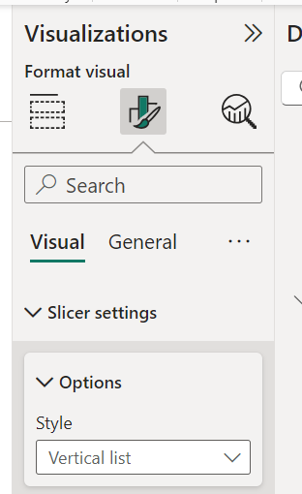

* + Interact with charts by selecting a year (e.g., 2019) and a province (e.g., New York) to view filtered sales on the KPI Card.

**8. Dashboards - Filters in Power BI, Formatting dashboards.**

**Dashboards - Filters & Formatting in Power BI**

**Dataset: *HR Data.xlsx***

* Open Power BI → Blank Report → *Get Data → Excel Workbook*.
* Select *Table 1* from the Navigator choose option “*Transform”*.

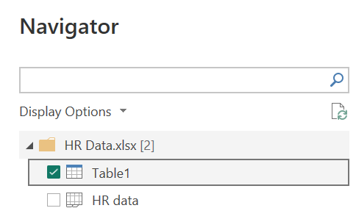

* Add a Conditional Column named “*Attrition Count”* and add as below.

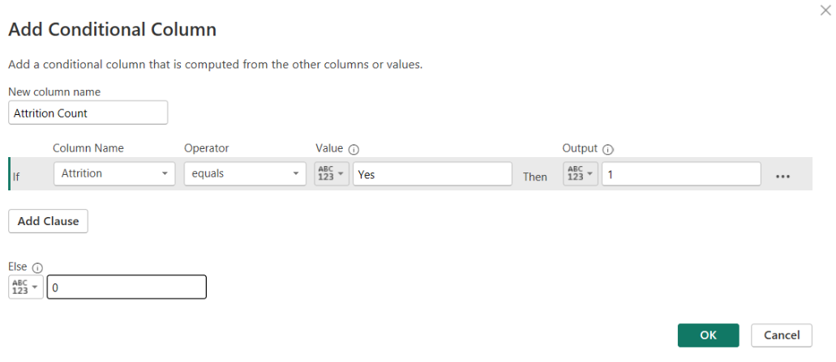

* Change its datatype to *Whole Number*.
* Click *Close & Apply*.

**Canvas Design:**

1. **Background Color:**
   * Go to *Visualization → Format your report page → Canvas Background*.
   * Choose a color and adjust transparency.



1. **Title:**
   * Add a text box → Type *"Filters and Formatting Dashboard"*.
   * Style it: Bold, Underline, Center-aligned, Font size, and Background color (*Effects → Background Color*).



1. **KPI Card:**
   * Go to “Visualizations→Build Visual”, Choose “Card”. Drag and Drop “Employee Count”

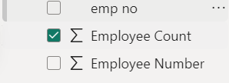

* + Rename the title to *"Overall Employees"* through ,”*Format your visual” → General → Title (ON)*.

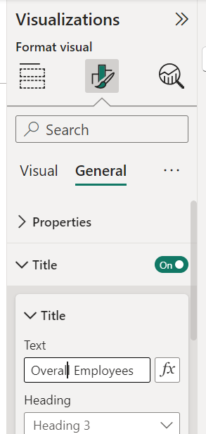

* + Customize background and text color. Go to Visual Tab→ OFF the category label

1. **Pie Chart:**
   * Select “Pie Chart” from Visualization pane.

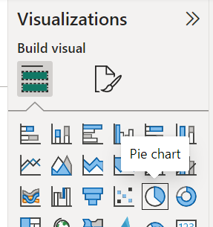

* + Drag *Department* to LEGEND and *Attrition Count* to VALUES.
  + Rename title to *"Department-wise Attrition"* (*Format Visual → General → Title*).
  + Customize background.

1. **Stacked Column Chart:**
   * Select “Stacked Column Chart” from Visualization pane
   * Drag *Age Band* to X-AXIS, *Employee Count* to Y-AXIS, and *Gender* to LEGEND.
   * Rename title to *"Age & Gender-wise Employee Count"*.
2. **Donut Chart:**
   * Select a “Donut” from Visualization pane
   * Drag *Gender* to LEGEND and *Attrition Count* to VALUES.
   * Rename title to *"Gender-wise Attrition Count"*.
3. **Slicer:**
   * Select “Slicer” from Visualization Pane
   * Drag “*Department”* to “*Filters on this visual”* Or Click the check mark beside “*Department”*
   * Add *Slicer → Format your visual → Visual → Slicer Settings →* give it as “TILE”.

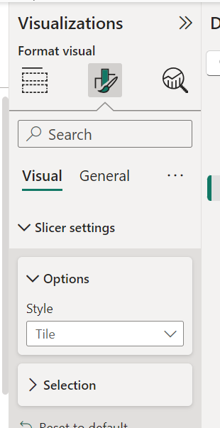

* + Change the title as “Department”.
  + Rename title to *"Department"*.
  + *Format your visual→ Visual→Selection→choose “Show – Select All” as ON*.

**9 Analysis of revenue in sales dataset:**

**i) Create a choropleth map (fill the map) to spot the special trends to show the state which has the highest revenue.**

**ii) Create a line chart to show the revenue based on the month of the year.**

**iii) Create a bin of size 10 for the age measure to create a new dimension to show the revenue.**

**iv) Create a donut chart view to show the percentage of revenue per region by creating zero access in the calculated field.**

**v) Create a butterfly chart by reversing the bar chart to compare female & male revenue based on product category.**

**vi) Create a calculated field to show the average revenue per state & display profitable & non-profitable state.**

**vii) Build a dashboard.**

**Revenue Sales Dashboard - Steps**

**Dataset:** *Revenue Sales Data.xlsx* (No transformation required; load data directly).

1. **Filled Map:**
   * Bring the “Filled Map” to the Canvas Background

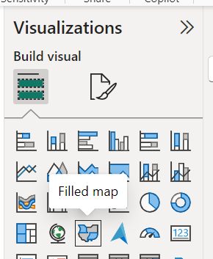

* + Drag *State* to *LOCATION* and also to *LEGEND*.
  + Drag *Revenue* to *TOOLTIP* → Set to *Maximum*.

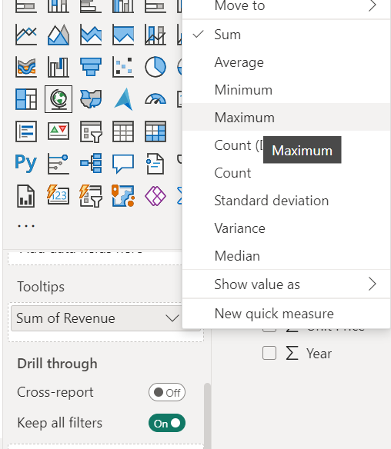

1. **Line Chart:**
   * Drag *Revenue* to *Y-AXIS*
   * *Drag Month* to *X-AXIS*.
2. **Stacked Column Chart (Customer Age Bins):**
   * Right-click *Customer Age* → *New Group* → Give the “Bin Size” as 10 and click “OK”.
   * Drag *Customer Age (Bin)* to *X-AXIS* and Drag *Revenue* to *Y-AXIS*.
3. **Donut Chart (Revenue % per Region):**
   * Drag *State* to *LEGEND* and *Revenue* to *VALUES*.
   * To show the percentage, Format Visual → *Detail Labels → Position → Inside*.
4. **Butterfly Chart (Gender Revenue by Product):**
   * Use a *Stacked Column Chart*.
   * Drag *Product Category* to *X-AXIS*, *Revenue* to *Y-AXIS*, and *Customer Gender* to *LEGEND*.
5. **Average Revenue per State (Profitable vs. Non-Profitable):**
   * *Click on “New Measure” from the ribbon(HOME Tab)*

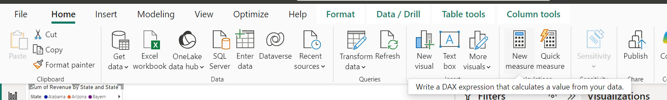

* + Formula: AveragePerState = AVERAGEX(VALUES(SalesTable[State]), CALCULATE(SUM(SalesTable[Revenue])))



* + Bring a “Table” to the canvas.
  + Drag *State* and *AveragePerState* both to *COLUMNS*.
  + *Go to “Modelling→New Column”. Here give the formula as follows;*

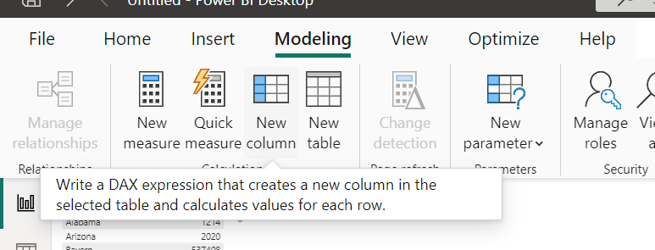

*ProfileStatus = IF(SalesTable[AveragePerState]>1000,"Profitable","Not Profitable")*

**

* + *Drag ProfitStatus to COLUMNS.*

1. **Dashboard Title:**
   * Add *Text Box*: Title → "Revenue Sales Dashboard".
   * Style title and background as desired.

**10. Analysis of GDP dataset:**

**i) Visualize the countries data given in the dataset with respect to latitude and longitude along with**

**country name using symbol maps.**

**ii) Create a bar graph to compare GDP of Belgium between 2006 – 2026.**

**iii) Using pie chart, visualize the GDP of India, Nepal, Romania, South Asia, Singapore by the year 2010.**

**iv) Visualize the countries Bhutan & Costa Rica competing in terms of GDP.**

**v) Create a scatter plot or circle views of GDP of Mexico, Algeria, Fiji, Estonia from 2004 to 2006.**

**vi) Build an interactive dashboard.**

**Dataset: *GDP by Country per Year_data.xlsx***

1. **Symbol Maps (Countries by GDP and Location)**
   * Drag *Latitude* to *ROWS* and *Longitude* to *COLUMNS*.
   * Drag *Country* to *Color Marks Pane* and a *Year Measured Value* to *LABEL*.
2. **Bar Graph (Belgium's GDP: 2006–2026)**
   * Drag “Measure Names” to “Filter” and select the years from 2006 to 2012.
   * Drag “Country” to “Filter” and choose only “Belgium”
   * Drag “Measure Names” & “Country” into the “Columns”.
   * Drag “Measure Values” into the “Rows”.
3. **Pie Chart (GDP of Select Countries in 2010)**
   * Filter *Country* (India, Nepal, Romania, South Asia, Singapore) and *Measure Names* (2010).
   * Select *Pie Chart* in Marks Pane.
   * Drag “Country” to the “Filter Pane” and choose “India, Nepal, Romania, South Asia, Singapore”
   * Drag “Measure Name” to the “Filter Pane” and choose the year “2010”.
   * Select option of chart as Pie(instead of automatic in Marks Pane) and Drag “Country” into Color frame.
   * Drag “Measure Values” into the “Angle”.
4. **Comparison (Bhutan vs. Costa Rica GDP)**
   * Drag “Country” into the “Filter Pane” and choose Bhutan, Costa Rica.
   * Drag “Measure Names” into the “Filter Pane” and choose the years 2016,2017,2018
   * Now, drag “Country” and “Measure Names” in column
   * Drag “Measure Values” in Row
   * For better view, drag “Measure Names” into the Color frame in Marks pane
5. **Scatter Plot (GDP of Mexico, Algeria, Fiji, Estonia: 2004–2006)**
   * Drag “Country” into the “Filter” and choose “Mexico, Algeria, Fiji, Estonia”
   * Drag “Measure Names” into the “Filter” and choose the year 2004,2005,2006.
   * Drag “Measure Names” and “Country” to the “COLUMNS”
   * Drag “Measure Values” to the “ROWS”
   * For a better view, drag “Country” to the “Color” in the Marks Pane.
6. **Interactive Dashboard**
   * Create a *Floating Dashboard*.
   * Add sheets from Steps 1–5.

**11. Analysis of HR Dataset:**

**i)Create KPI to show employee count, attrition count, attrition rate, attrition count, active employees, and average age.**

**ii) Create a Lollipop Chart to show the attrition rate based on gender category.**

**iii) Create a pie chart to show the attrition percentage based on Department Category- Drag department into colours and change automatic to pie. Entire view, Drag attrition count to angle. Label attrition count, change to percent, add total also, edit label.**

**iv) Create a bar chart to display the number of employees by Age group,**

**v) Create a highlight table to show the Job Satisfaction Rating for each job role based on employee count.**

**vi) Create a horizontal bar chart to show the attrition count for each Education field Education field wise attrition – drag education field to rows, sum attrition count to col,**

**vii) Create multiple donut chart to show the Attrition Rate by Gender for different Age group.**

**Power BI Visualization Steps for *HR Analytics Data.csv***

**Dataset Preparation**

1. **Rename the table from *HR Analytics Data* to *HR* for easier access.**

**Steps to Create Visualizations**

**1. Create KPI Metrics for HR Dashboard**

* Employee Count
  + Create a measure:
  + Employee Count = COUNT(HR[EmployeeNumber])
  + Add a KPI Card with this measure.
* Attrition Count
  + Create a measure:
  + Attrition Count = COUNTROWS(FILTER(HR, HR[Attrition] = "Yes"))
  + Add a KPI Card with this measure.
* Attrition Rate
  + Create a measure:
  + Attrition Rate = DIVIDE([Attrition Count], [Employee Count], 0) * 100
  + Add a KPI Card with this measure.
* Active Employees
  + Create a measure:
  + Active Employees = [Employee Count] - [Attrition Count]
  + Add a KPI Card with this measure.
* Average Age
  + Create a measure:
  + Average Age = AVERAGE(HR[Age])
  + Add a KPI Card with this measure.
* **Dashboard Customization** 
  + **Set the canvas background color and title as *HR Dashboard*.**

**2. Lollipop Chart: Attrition Rate by Gender**

* Add a *Line & Stacked Column Chart*.
* Drag *Gender* to *X-Axis*.
* Drag *Attrition Count* to *Column Y-Axis*.
* Drag *Attrition Rate* to *Line Y-Axis*.

**3. Pie Chart: Attrition by Department**

* Add a *Pie Chart*.
* Drag *Department* to *LEGEND*.
* Drag *Attrition Count* to *VALUES*.
* Customize labels: show percentages and total count.

**4. Bar Chart: Employees by Age Group**

* Create an *Age Group BIN* with size 10:
  + Right-click *Age* → *New Group* → Name as *Age Group* → Bin Size: 10.
* Add a *Stacked Bar Chart*.
* Drag *Age Group* to *Y-Axis*.
* Drag *Employee Count* to *X-Axis*.

**5.** Highlight Table: Job Satisfaction by Job Role

* Add a *Matrix*.
* Drag *Job Role* to *ROWS*.
* Drag *Job Satisfaction* to *COLUMNS*.
* Drag *Employee Count* to *VALUES*.

**6.** Horizontal Bar Chart: Attrition by Education Field

* Add a *Stacked Bar Chart*.
* Drag *Education Field* to *Y-Axis*.
* Drag *Attrition Count* to *X-Axis***.**

**7.** Donut Charts: Attrition Rate by Gender and Age Group

* Add a *Donut Chart*.
* Drag *Gender* to *LEGEND*.
* Drag *Attrition Rate* to *VALUES*.
* Drag *Age Group* to *Filters on this Visual* → Select Age Group = 30.

**12 Analysis of Amazon Prime Dataset:**

**i) Create a Donut chart to show the percentage of movie and tv shows**

**ii) Create a area chart to shows by release year and type**

**iii) Create a horizontal bar chart to show Top 10 genre**

**iv) Create a map to display total shows by country**

**v) Create a text sheet to show the description of any movie/movies.**

**vi) Build an interactive Dashboard.**

Choose the Dataset “Amazon-Prime-Titles.csv”. Transform the data as follows;

Rename the field “listed in” as “Genre”

Remove “Duration”, “Rating”, “date_added”, ”cast”, ”director”

Click “Close &amp; Apply”

Change the Table name from “Amazon-Prime-Titles” to “Amazon” by just double-clicking

on the table name, for our easy access purpose.

1. Create a Donut chart to show the percentage of movie and tv shows.

* Bring a Donut into the canvas.
* Drag “type” into “LEGEND”. (If the type is showing other than MOVIE &amp; TV Show,
* then transform and choose only these two values)
* Drag “show id” into “VALUES”

2. Create an area chart to shows by release year and type.

* Bring Area Chart into the canvas.
* Drag “Release Year” into “X-AXIS”
* Drag “type” into “Y-AXIS”
* Drag “type” into “LEGEND” to analyse both TV Shows &amp; Movie separately.

3. Create a horizontal bar chart to show Top 10 genre.

* Bring Clustered Bar Chart into the canvas
* Drag “Genre” into “Y-AXIS”
* Drag “title” into “X-AXIS”
* To display only Top 10 Genre, do the following steps;
* In Filters, choose Filter Type as “Top N”, mention the value “10” under show items
* , Drag “Genre” into “By Value”.

4. Create a map to display total shows by country.

* Bring Filled Map into the canvas.
* Drag “Country” into “LOCATION”
* Drag “Show ID” into “TOOLTIP” and change it to “Count” of “ShowID” under ToolTip

5. Create a text sheet to show the description of any movie/movies.

* Bring Table into the canvas.
* Drag “title” into “COLUMNS”
* Drag “description” into “COLUMNS”

6. Build an interactive Dashboard.